National College of Ireland

Project Proposal
Cybersecurity Intrusion Detection & Consolidated Testing Utility Application for Network, Web and Application-Level Threats.

16/10/2024
BSHCYB4
Cyber Security Specialisation
Academic Year 2024/2025
Timofey Sneyd
Student ID: x21755195
x21755195@student.ncirl.ie

Table of Contents

1.0 Objectives 2
2.0 Background 2
3.0 State of the Art 3
4.0 Technical Approach 3
5.0 Technical Details 4
6.0 Special Resources Required 4
7.0 Project Plan 5
8.0 Testing 6

1.0 Objectives
This project aims to develop a Cybersecurity Intrusion Detection & Consolidated Testing Utility Application for Network, Web and Application-Level Threats designed to simplify and automate standard cybersecurity tasks. The tool will provide users with a user-friendly interface to perform the following tests along with others consistent with NIST, ISO, OWASP, SANS and other industry best practices in Cybersecurity:
- Network configuration analysis
- Port scanning
- Basic vulnerability checks
- ARP scanning and spoofing detection
- SQL injection tests
- Others (TBA)
Note for the reader: Currently the tool has been developed as a terminal/command-prompt launched tool but could be changed to something different in terms of interface and visual examples of it to take a closer look at it will be given on the next page of this proposal document.
In the long term, the project will evolve to incorporate machine learning (ML) and artificial intelligence (AI), enabling advanced features such as predictive vulnerability detection and dynamic threat response. The goal is to make sophisticated network security practices accessible to both professionals and novices.
In terms of profit making in future this tool can be used as a direct tool given to use within a personal company to offer cybersecurity services for other companies either to look for vulnerabilities in their system or to reinsure that their system is safe.
This tool could be in other business scenario be sold as an educational product or platform to show or to teach others how to look for vulnerable sides of the systems as it allows users to customize payloads (e.g. SQL injection), parameters and many other specific settings to test while performing a simulated attack, therefore the tool has adaptable functions and parameters inside of it and that is the main point of this tool because it has and will have more different functionality focusing in cybersecurity direction.
On the final stage of the development of this tool depending on the business opportunities this tool can be adapted even more or edited to the required customers audience and again this tool first of all is aimed to provide a service to other services and will be acting from a company’s name staff of which would be using this tool in the business idea for future.

Visual Short Example of the tool
Here is the visual example of current draft developing stage of the tool:
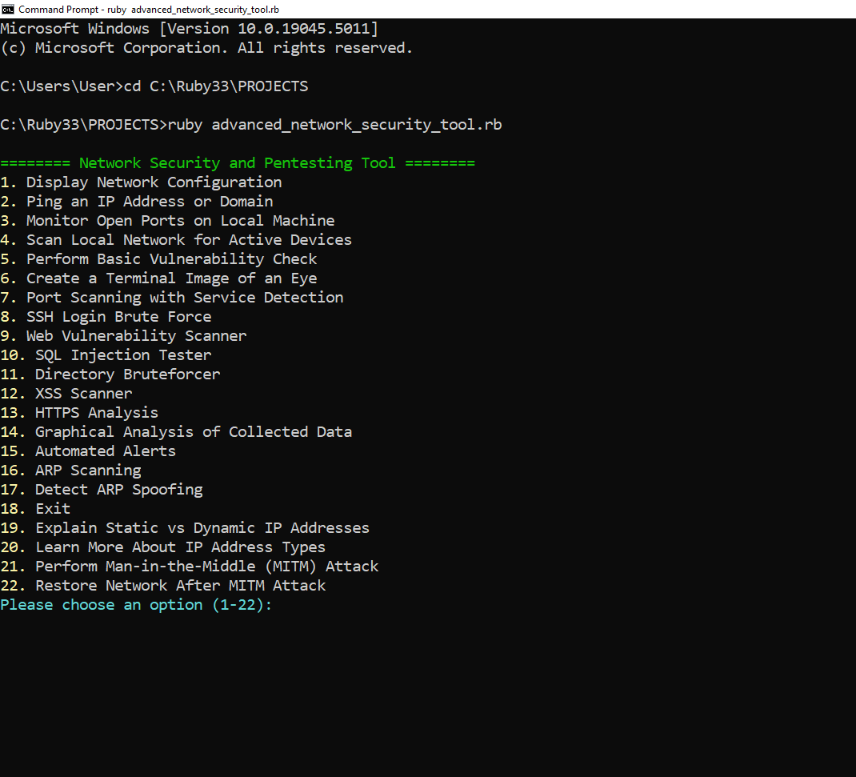
-The menu list of tool’s functionality is not yet full and a research is been made on what types of cybersecurity issues are out there and therefore this menu list and the tool itself will have more functionality given for users to test.

2.0 Background
This project was initiated to address the increasing demand for accessible cybersecurity tools that cater to both experienced professionals and beginners. The current cybersecurity landscape is filled with powerful tools like Nmap, Wireshark, and Metasploit, which often come with steep learning curves. Our tool aims to bridge that gap by:
- Offering automated processes for common and more advanced/customised security tests.
- Providing visual feedback and step-by-step guidance to assist users in understanding the results.
- Evolving into a more robust tool with ML/AI integration for predictive threat detection due to its potential on the market as in profit, in productivity and in effectiveness which would save time for users instead of using classic tools.
The objectives of this project will be met by continuously expanding the tool's functionality, beginning with the current set of features and moving towards more advanced applications of machine learning in cybersecurity.

3.0 State of the Art
Several classic tools exist in the network security and pentesting domain, including:
- Nmap: Known for its powerful port scanning capabilities.
- Wireshark: A widely used tool for packet analysis.
- Metasploit: A framework for exploiting vulnerabilities.
However, our project stands out by focusing on:
- User accessibility: Simplified, intuitive interface with visual feedback.
- Automation: Minimizing manual intervention in common security tasks.
- Individual specific requirements of users behind the tool’s code which can adapt to those requirements in moments, for example:
working with different prefixes/addresses or for testing SQL injection where different types of payloads required to be created depending on the target and the user will be able to use different parameters with required url to test possible vulnerabilities.
- Future AI/ML integration: Long-term focus on automating vulnerability detection and adapting to new threats in real time.

4.0 Technical Approach
The project will follow an iterative development process, beginning with the core functionalities and progressively adding advanced features. The approach involves:
- Identifying requirements:
- Standard pentesting tasks such as ARP scanning, SQL injection tests, and port scanning.
- Feedback from users and cybersecurity professionals.
- Breaking down requirements into development milestones:
Phase 1: Implement core features (e.g., network configuration, basic port scanning, vulnerability checks).
Phase 2: Introduce advanced functionalities (e.g. AI-driven detection, dynamic response mechanisms).
Phase 3: Testing and user feedback integration.
Key activities and deliverables include:
- Developing a structured task list with clear milestones for each phase.
- Performing regular testing and integrating feedback to enhance tool usability and functionality.
- Exploring AI/ML frameworks for long-term expansion.

5.0 Technical Details
The tool is primarily built using Ruby with the following key libraries:
- socket: Used for network operations.
- net/http and uri: Handle web requests.
- JSON: For structured data management.
- colorize: Adds color and visual cues for better user feedback in the terminal.
Key functionalities include:
- ARP Scanning: Discovers active devices on the local network and identifies potential ARP spoofing attacks.
- Port Scanning with Service Detection: Detects open ports and identifies associated services.
- SQL Injection Testing: Provides simulated tests for common SQL vulnerabilities.
Looking ahead, we aim to explore:
- AI/ML-driven threat detection.
- Advanced algorithms for real-time traffic analysis and predictive anomaly detection.

6.0 Special Resources Required
No special hardware is required for the core functionality of this tool. However, as there are some ethical issues regarding pentesting and the targets that the users would try to test on vulnerabilities and the project evolves to incorporate AI/ML:
- It will be required to hold or have a trusted/authorised or personal websites, applications, networks for users who will be testing those functions from the tool in order to be able to work ethically with possibly sensitive information stored in those apps, websites etc.
- Machine Learning Frameworks: We will integrate libraries such as TensorFlow or PyTorch.
- Cloud Computing Resources: For training models and handling large-scale data analysis.
- Access to a Simulated Lab Environment: For testing security vulnerabilities in a controlled, ethical setting.

7.0 Project Plan
The project is broken down into possibility of three key phases, each with a set of milestones and deliverables:
Phase 1: Core Functionality (Weeks 1-4)
- Week 1:
- Develop initial menu interface and basic features (network configuration, open ports monitoring, ping functionality).
- Week 2:
- Implement vulnerability checking, SQL injection testing, ARP scanning.
- Week 3:
- Add ARP spoofing detection and data-saving functionality.
- Week 4:
- Begin testing on local networks, gather user feedback, and iterate based on results.
Phase 2: Advanced Features (Weeks 5-8)
- Week 5:
- Develop additional features (XSS scanner, directory brute forcing).
- Week 6:
- Implement more complex features (HTTPS analysis, automated alerts).
- Week 7:
- Explore ML/AI integration for predictive vulnerability detection.
- Week 8:
- Finalize ML/AI integration and prepare for real-world network testing.
Phase 3: Testing and Evaluation (Weeks 9-10)
- Week 9:
- Conduct integration tests to ensure different modules work together.
- Evaluate the tool’s performance under various network conditions.
- Week 10:
- Perform user evaluations (ethics considerations included) and refine the tool accordingly.

8.0 Testing
The tool will require a lot of testing even already at the development stage as it’s purpose and idea may sound interesting from the name and the business idea but it will undergo a demanding evaluation process, involving:
- System Testing:
- Each feature (e.g., ARP scanning, port scanning, SQL testing) will be individually tested for correct functionality.
- Integration Testing:
- Multiple functionalities will be tested together to ensure seamless interaction (e.g., ARP scanning followed by spoof detection). Therefore, there will be tests of 2 or more functions combined for some scenario together
- Performance Testing:
- The tool’s performance will be assessed in different network environments (e.g., possibly under heavy traffic, various network configurations if will be required).
- User Testing:
- Testing will involve users from different backgrounds, providing feedback on usability and experience of user.
- Ethics will be considered, ensuring no real networks or sensitive data are compromised during testing.
- White Box and Black Box Testing:
- White Box Testing: The internal structures of the tool will be tested to verify how well the code is functioning, ensuring that the logic, flow, and individual modules work as intended. This will involve examining the internal code, debugging processes, and running test cases for specific code paths.
- Black Box Testing: This will focus on testing the tool’s external behaviour, without regard to the internal code. We will test input/output functionality, validating that the tool performs correctly across its features (e.g., providing accurate results for ARP scans, port monitoring, or vulnerability checks), ensuring user expectations are met without considering the underlying code structure.

